# Identify Suitable Colour Schemes for TopShooter

When making any website or application developers must decide on an effective colour scheme that will not only suit the product being provided but must be appropriate to the applications potential users as well as allow for those with visual impairments to enjoy the product. Choosing the incorrect colour schemes can lead to the readability and accessibility of the developed product becoming unreadable or unusable to some users and in some cases even the development team. If visuals shown use product pictures or even headlines with important messages for users. When developing the pages, the developer should stick to desaturated background colours so that the images or headlines will stand out against it. Using a saturated background will make the content of the page hard to read but any images will lose their effectiveness against the saturated background colour, this can also make the application difficult to navigate.

The development team of TopShooter have decided upon several possible colour schemes for the game to utilise while taking accessibility into account. The following schemes are still to be decided upon by the team.

## Menu Colour Scheme

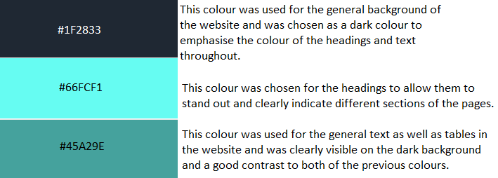

## Game Colour Scheme

### Cyberpunk Neon Theme

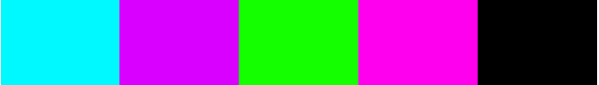

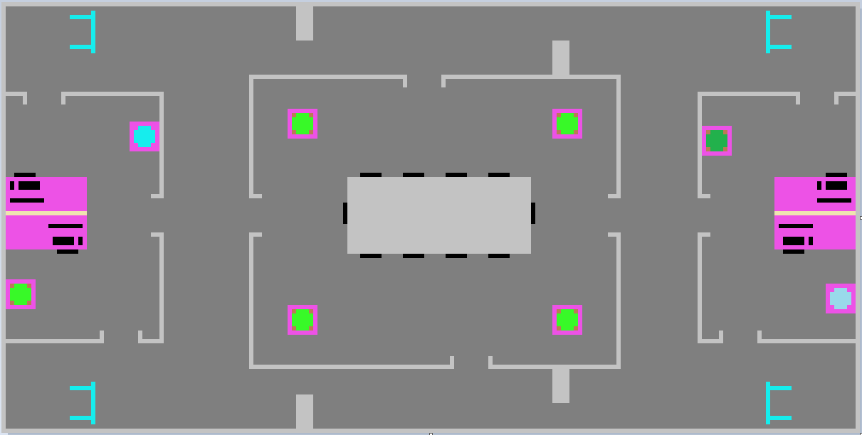

### Fallout Apocalypse Theme



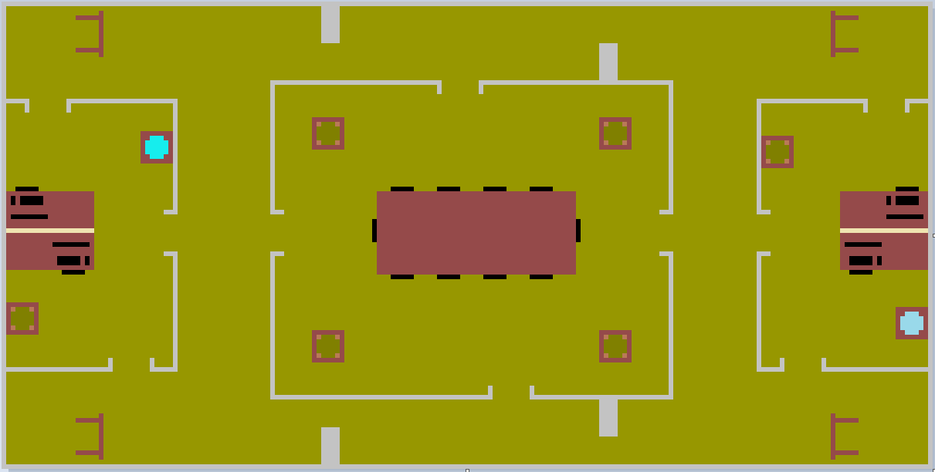

### Noir Bar Theme



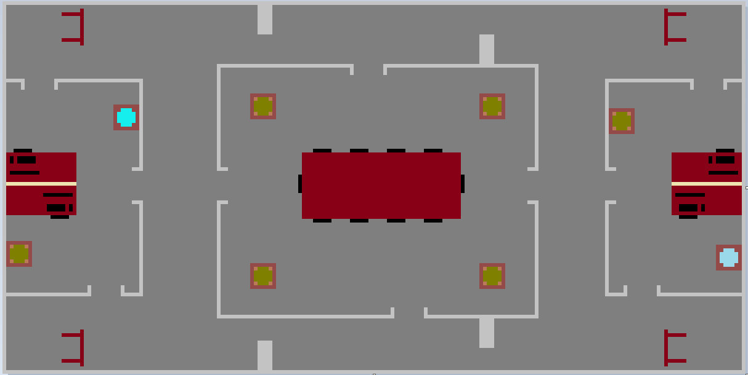

### Hellscape Theme



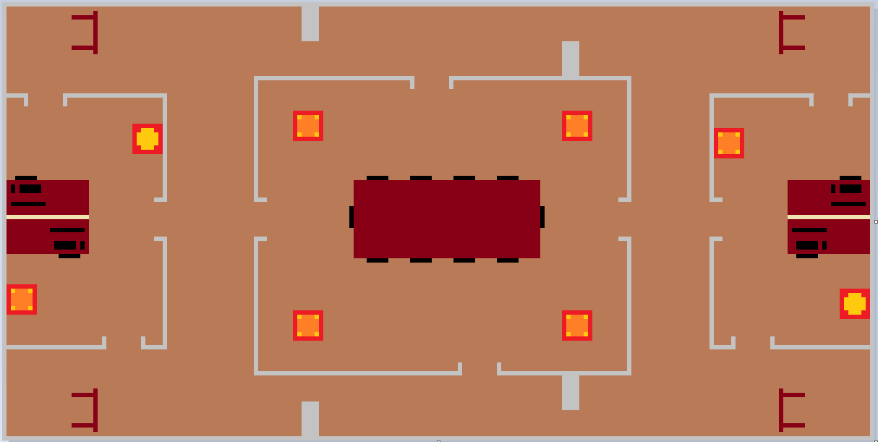

### Tropics Theme



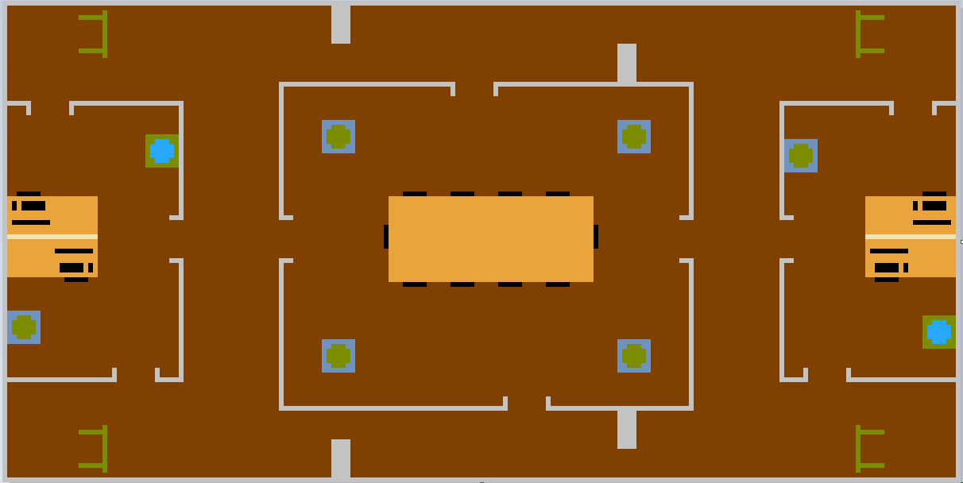

Each of the maps shown for the prototype utilise desaturated base colours to allow for the objects within the map to stand out, the use of continuous grey to indicate walls was also used to contrast well with the desaturated background colour.

Accessibility

With these background colours in mind the team will now need to employ accessibility options for those with visual impairments such as colour blindness. Colour blindness can affect people differently and can be a challenge to add option for every player, but the team have researched various ways of alleviating this problem, the following are examples of ways in which the team can add accessibility for more users.

Simplfy Sprites

Strict Colours